LAB 2

SUBJECT: Algorithms, Compiling, Debugging
Goal: Enter and compile a program.

- Write an algorithm (psuedo code) to calculate the shaded area of the object below
Algorithm should be general: It should work for all values of A,B,C,D and different number of boxes (drawing below shows 3 x 3 shaded boxes and 1 x 1 white boxes). Do not assume A=B or C=D (as shown in the first diagram). Do not assume that the boxes are 3x3 and 1x 1. Dimensions A & B refer to the small box indicated by the dotted line. The second image shows a second possible object. Your algorithm should work for both images. USE GOOD VARIABLE NAMES (NOT ABCD).

B

A

D
C

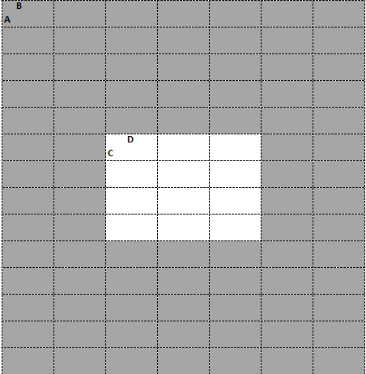
Variable -
int DarkHeight // Side A
int DarkBase // Side B
int WhiteHeight // Side C
int WhiteBase // Side D
int NumberofHorizontalboxDark
int NumberofHorizontalboxWhite
int NumberofVerticalBoxDark
int NumberofVerticalBoxWhite

Formula –
Area = (Darkheight * DarkBase) * (NumberofHorizontalboxDark * NumberofVerticalBoxDark) - (WhiteBase * Whitehight) * (NumberofHorizontalboxWhite * NumberofVerticalBoxWhite)

- Write an algorithm to calculate the interest on a loan and the remaining balance after a specified payment is made. Interest and payment are made at the end of the year
Variables -
float principal;
float amountpaid;
float intrestrate;
float remainingbalance;
float intrestamount;
float totalamountdue;

Formula –

totalamountdue = (principal * intrestrate);
intrestamount = (totalamountdue - principal);
remainingbalance = (principal - amountpaid)+ totalamountdue;

- Write an algorithm to determine insurance company payment and your payment
You may assume that the total charges are greater than the deductible

Deductible $1000 – you pay all charges until this amount is reached.
Co pay 20% after the deductible – after the deductible is used you pay this amount of charges
Variable -
float deductible, iPayCoPay;
float coPay, companyPay, companyCoPay;
float totalCharges;
float totalPay, totalCompanyPay;

Formula -
companypay = totalcharges - deductible;
ipaycopay = companypay * copay;
totalpay = ipaycopay + deductible;
totalcompanypay = totalcharges - totalpay;

Prescription co pay $40 payment for each prescription, Insurance company pays rest. (not included in deductible)

Variable -
float prescriptionCost, coPay, netPay, insuranceCompanyPay;
int prescription;

Formaula-
netPay = (prescription * coPay);
insuranceCompanyPay = (prescriptionCost * prescription) - netPay;

The algorithm should be general but try the algorithm for this example
Total charges $5000
Prescriptions 3 for $65 each

********************************************************
Show me the algorithms before proceeding
********************************************************
- Write a program to do #1 above. Use good variable names (ABCD are NOT acceptable), Use programs for Lab1 as an example

- Write a program to do #2 above

- Write a program to do #3 above

- Look at the code of program 4. Enter the program, Add appropriate blank lines and tabs. Add appropriate comments, Add println’s as per your template compile and run it. Determine what algorithm is used and correct it if necessary.

- Hand in the source code for all programs and sample output. Code listing on top. Make sure you use appropriate comments and that your name is on all code and output.

//Program 4
public class Lab2d
{public static void main (String[] args)
{int sum;sum=0;sum=sum+96;sum=sum+70;sum=sum+85;sum=sum+60;
System.out.println("Sum is initially set to "+ sum);System.out.println("Sum is now "+ sum );
System.out.println("Sum is now "+ sum );System.out.println("Sum is now "+ sum );
System.out.println("The final sum is "+ sum );
}
}

